Git
Git summary of Operations

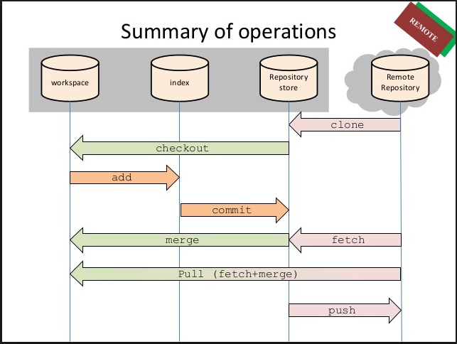

GIT Commands:
- git init
- Will initialize the present directory into VCS repository and add a configuration directory .git in the present directory and makes it to start recording versions of the project.
- git status
- Will show the current status of tracked and un tracked file

- git clone (e.g. git clone “URL of Repo”)
- Will clone the project from the master Repository
- git config ( git config user.name / git config user.email)
- Setting user name and email for every repository on your computer
- git pull
- fully update your local copy from the master ( Central Repository )

- git branch ( git branch mybranch)
- will create new branch with name as of mybranch

- git add (filename)
  - adds a particular file
- git add . ( period )
- adds all changed files
- git reset ( e.g. git reset git –add/ filename)
- Will remove any staged file from next commit
- git remote –v
- You have to upstream i.e on for main repository i.e project1 and one for your fork reporsitory of project1, so the following command looks like:
git remote -V :
- origin https://stash.ba.ssa.gov/users/userpin/repos/project.git (fetch)
  - origin https://stash.ba.ssa.gov/users/userpin/repos/project.git (push)
  - upstream ssh://git@stash.ba.ssa.gov/~userpin/projectname.git (fetch)
  - upstream ssh://git@stash.ba.ssa.gov/~userpin/projectname.git (push)
  - git remote set-url origin ssh://git@stash.ba.ssa.gov/~userpin/projectname.git
- git commit (e.g. git commit -m “ Message or comment” )
- will commit changes
git commit –amend
- The committed message will be open in your default editor, edit the message and save it.
- git push (git push –u origin branchname / master )
- 'Pushing' is when you actually upload all your hard work to the central Repository
- git stash ( list /show /drop /pop / apply /clear / create /store)
- git stash: when you want to record the current state of the working directory and the index, but want to go back to a clean working directory. The command saves your local modifications away and reverts the working directory to match the HEAD commit.
- list: List the stashes that you currently have. Each stash is listed with its name (e.g. stash@{0} is the latest stash, stash@{1} is the one before, etc.),
- Show: shows the changes recorded in the stash as a diff between the stashed state and its original parent. When no <stash> is given, shows the latest one. By default, the command shows the diffstat, but it will accept any format known to git diff (e.g., git stash show -p stash@{1} to view the second most recent stash in patch form). You can use stash.showStat and/or stash.showPatch config variables to change the default behavior.
- git merge: (git merge branchname / master )
- will merge changes from branch to master or master to branch

- git-fetch :
- Download objects and refs from another repository
e.g. git fetch origin
- The above command copies all branches from the remote refs/heads/ namespace and stores them to the local refs/remotes/origin/ namespace, unless the branch.<name>.fetch option is used to specify a non-default refspec.
Note : More options are available for git fetch not listed here

- GIT init: which creates GIT repository in .git folder : Create text file in the Project folder (Gitdemo) as mentioned here.
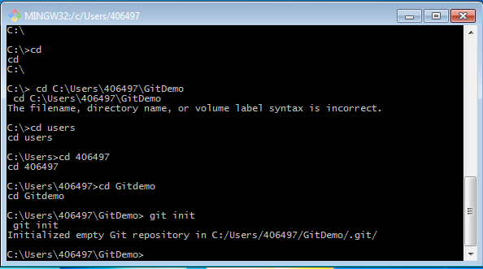
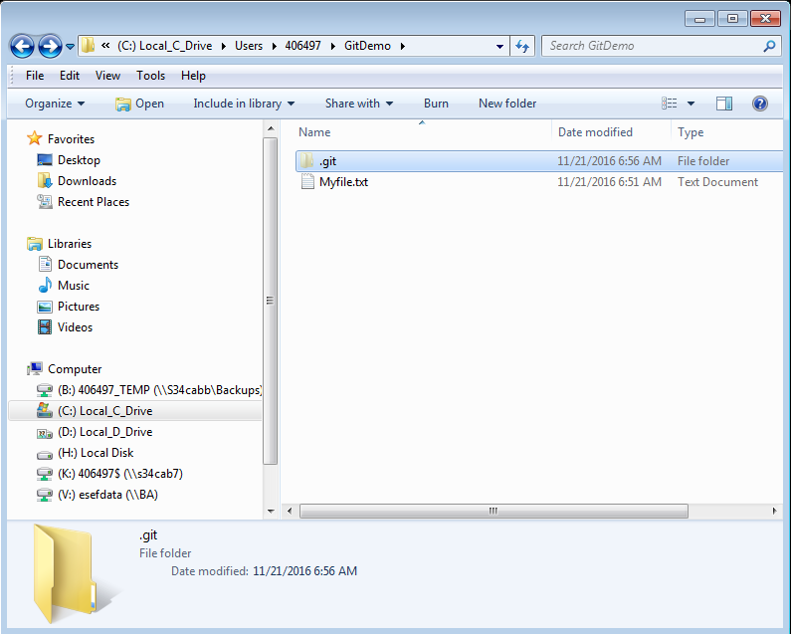

Step: 2
After creating file (project files)
Enter: “GIT Status” command on the Git , which shows that we have a untracked file

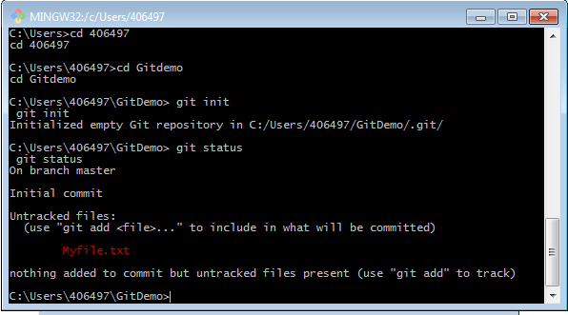

Staging :
We have stage our project file in GIT, e.g. here we have Myfile
Enter: git add Myfile.txt (project file):

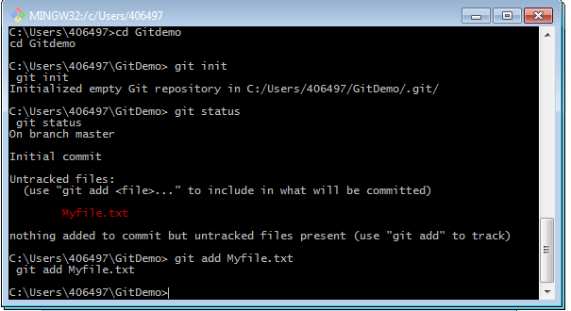

Step:3 : Check Status again:
“ git status “
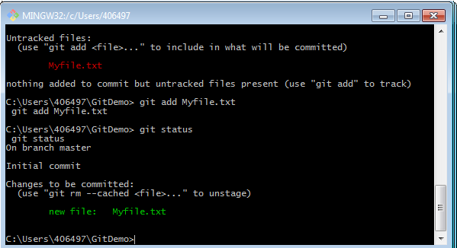

After staging any project file, if any team member make changes, Git will be recognize changes.

Change the file and save it…
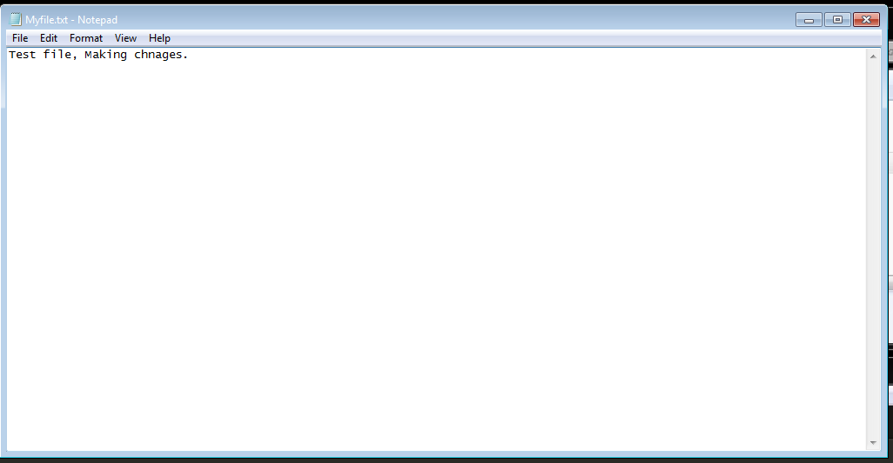

Check GIT Status again, GIT will show the modified file: Tracked and untracked file as mentioned below
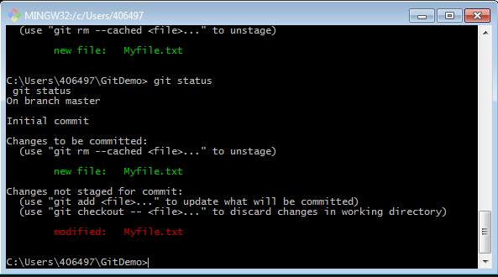

After making changes if we commit the file, it will not include our changes, so in order to include our changes we need to stage our file again.
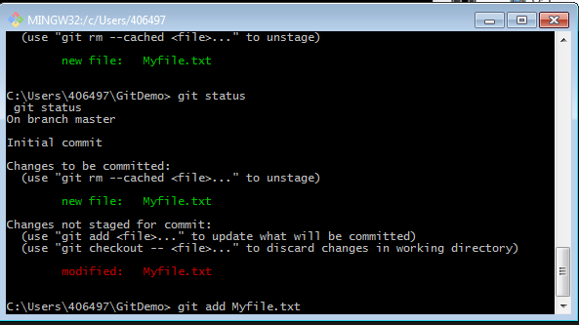

After staging file, check the status again: “ git add Myfile.txt ”
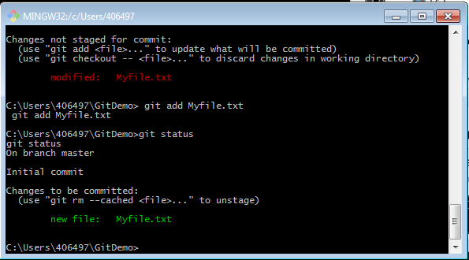

After making changes, we are ready to commit the file in the repository, (GIT COMMIT)

Type GIT COMMIT :

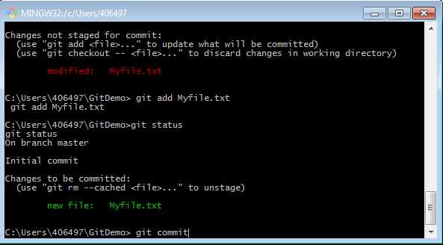

After committing file, Git will ask to enter commit message,

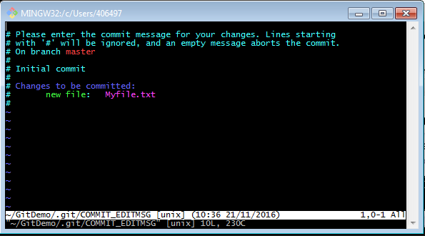

On this screen enter I ( i ), it will take us on Insert mode
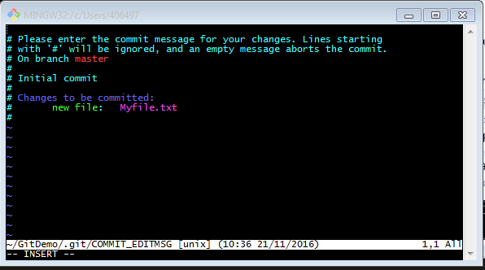

Type the message on the, insertion of message will appear on the top the screen
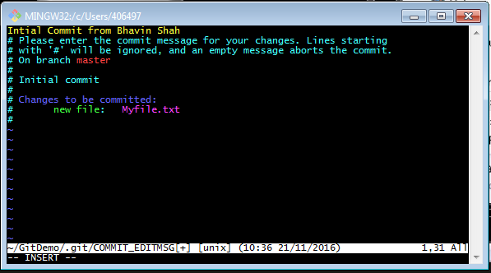

After entering the comment press Escape Key:

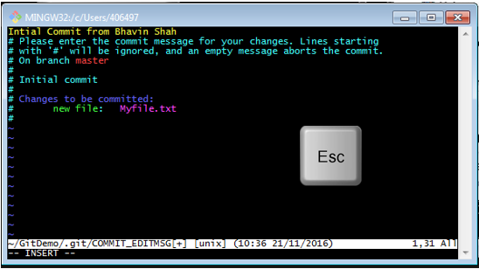

And Type “ :wq “ (colon wq) in lower case, which will rewrite current file and exit
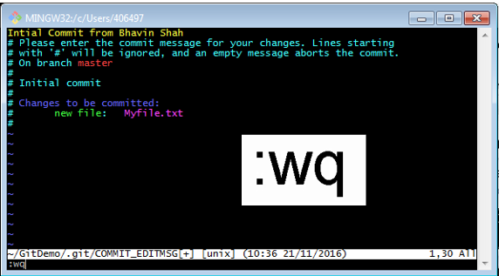

We have committed changes in file.

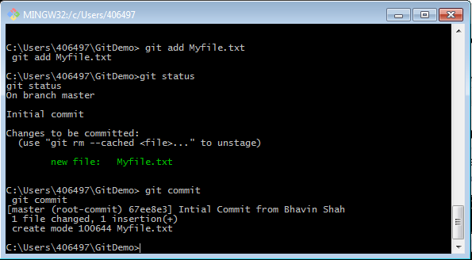

Check status again and notice that nothing to commit now and working directory is clean.

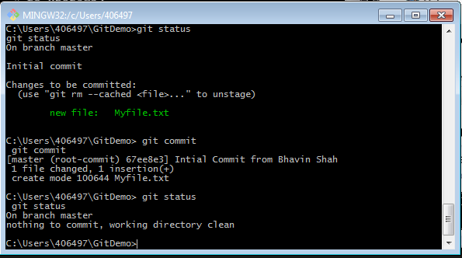

If we don’t want to see Initial commit message we can add modified file “ Git add Myfile.txt “ and enter “ Git commit –m + comment “
e.g. : git commit –m “my new changes”

Now let us make another change, save the file
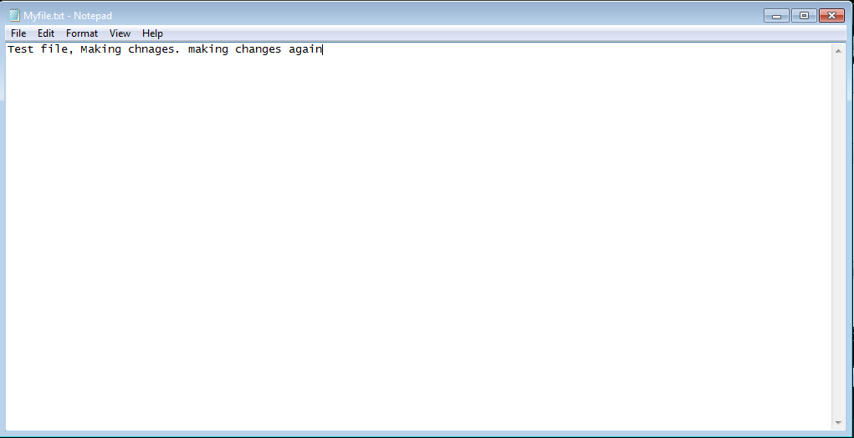

Now let us use the “ –m” key to commit changes.
Git shows new modification:
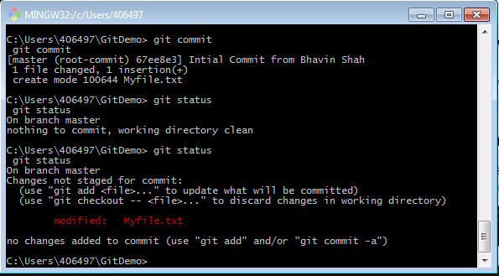
Adding file :
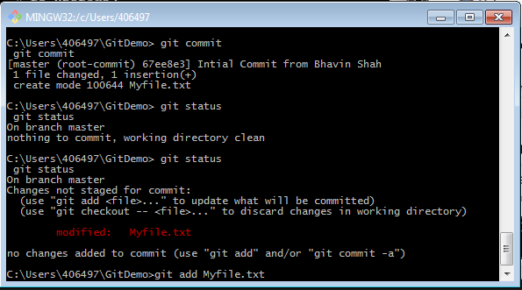

Committing change with “-m” key with message in quotes: (Which will not open the message screen);
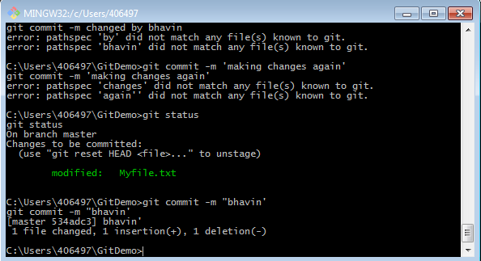

$ git log --pretty=oneline
$ git log –stat
Git LOG : To see all commits enter ‘git log “ :
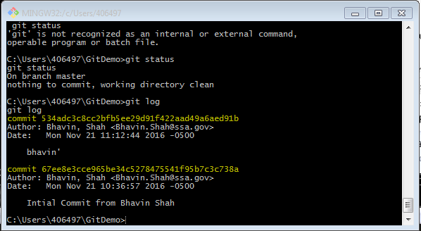
Adding New file in project: Add new html file :
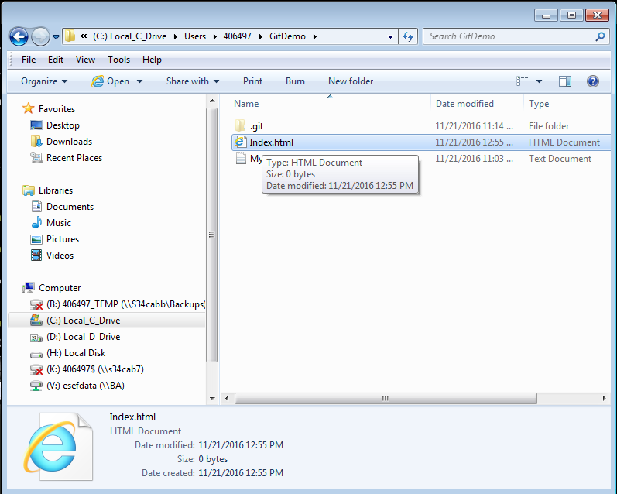

Git add with . (dot / period ) , which adds all newly added and changed files together.
e.g. : git add .
Let’s change the existing file and save it.
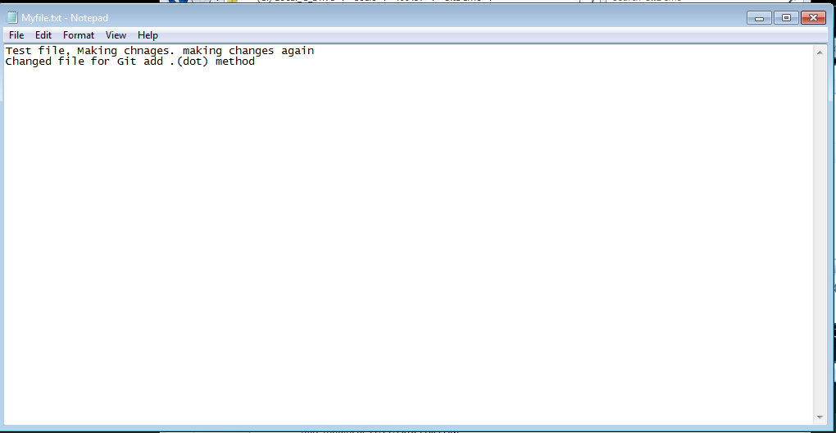

Let’s check the status,
Git shows modified and untracked file as shown below:

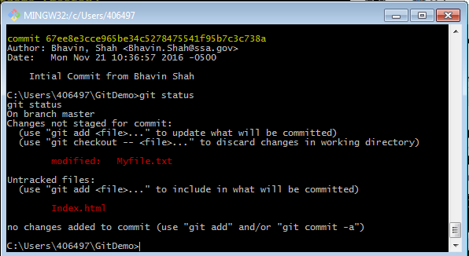

Now let’s add both file together using “.” (dot / period) :
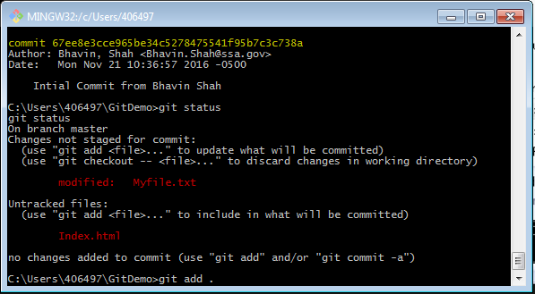
Press Enter ;
Check status: “git status “
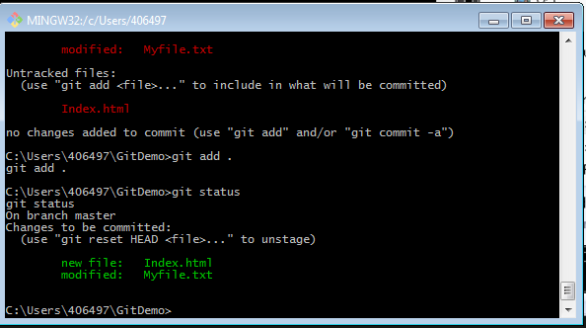
Both the files are staged now.
Note: To include any specific file use * (asterisk) as wild card.
e.g. git add *.html will only add html file/s.

Branching

In order to work on own copy of code we can create our own branch and other team members can work on their own task without interfering each other.
Command prompt: “git branch My branch”

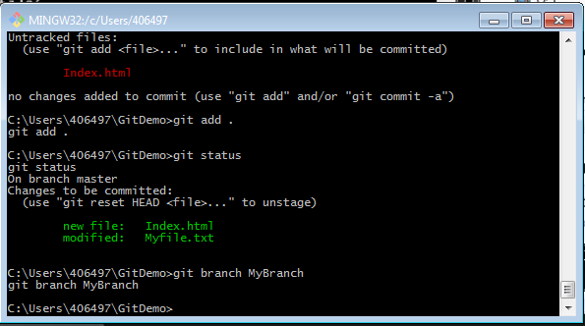

Switch to our own branch:
Command prompt: “ git checkout MyBranch”

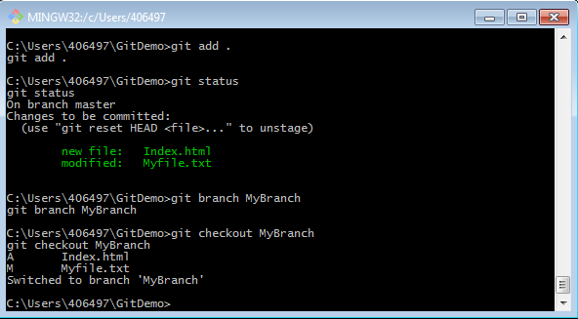

We can start to work on own branch after checkout.
Command prompt: “ git checkout MyBranch” : (11/22/2016)
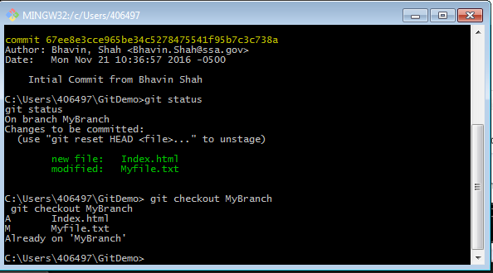

Add new file from Git command:
“touch index.css”

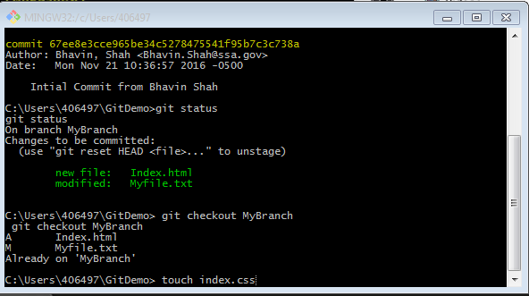

New file added in project folder:

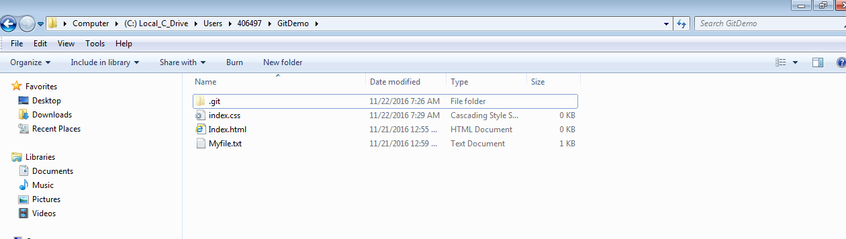

After creating new file, stage new file in repository: “ git add . ” ( git add . (dot / period))

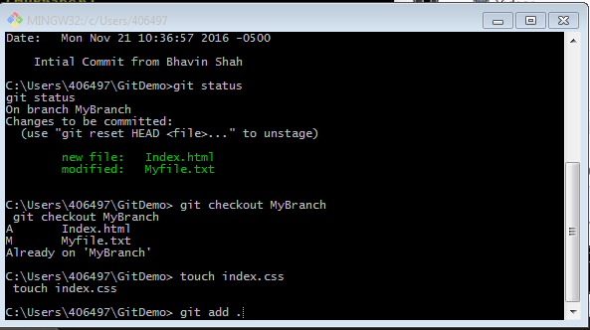

Check the status after staging file in repository: “ git status”
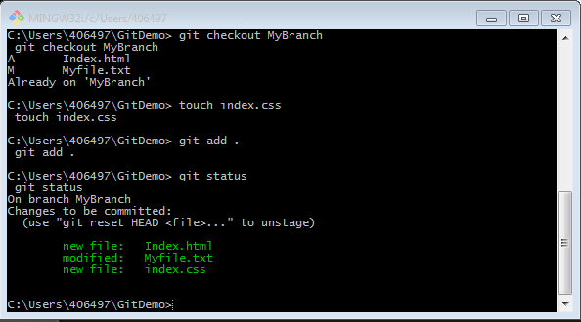

Going back to master branch: “ git checkout master”
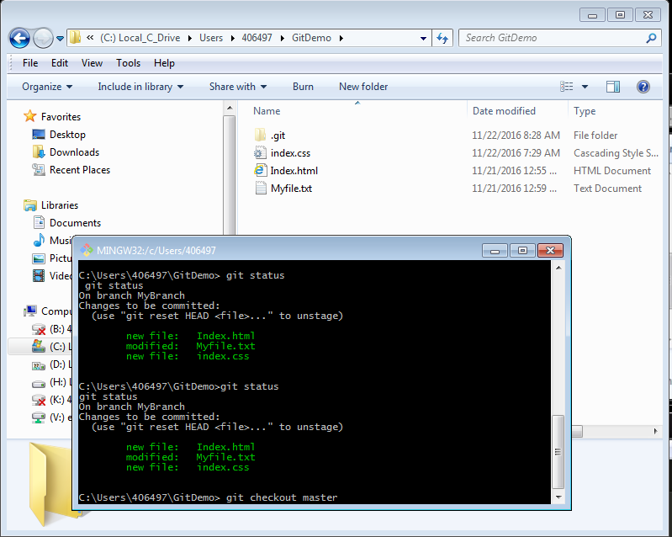

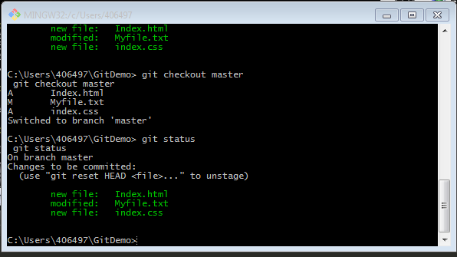
Basic Merge Conflicts:
Occasionally, this process does not go smoothly. If you changed the same part of the same file differently in the two branches and you’re merging together, Git won’t be able to merge them cleanly.

Checking out in MyBranch, and making changes to Myfile;

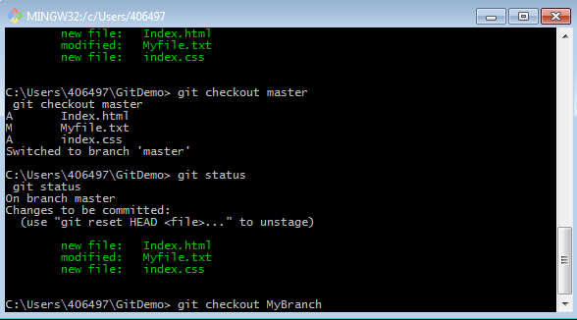

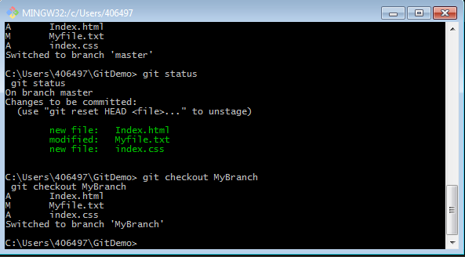
Changes made in file and saved from MyBranch:
“Git commit –a –m ‘comments “ will do two steps at the same time , 1) stage the file 2) commit changes

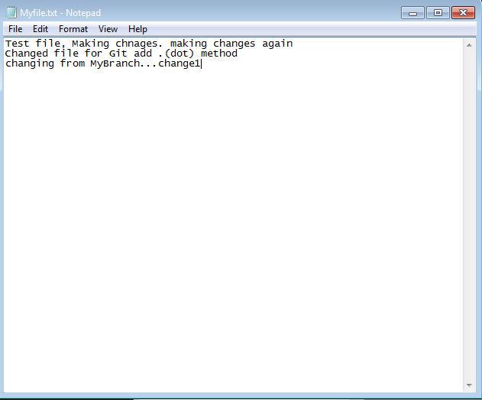

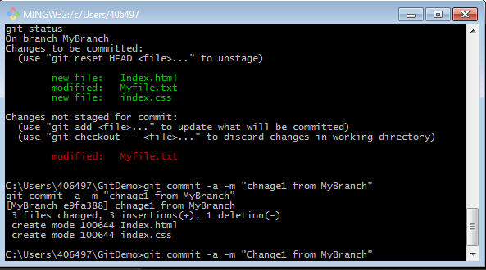

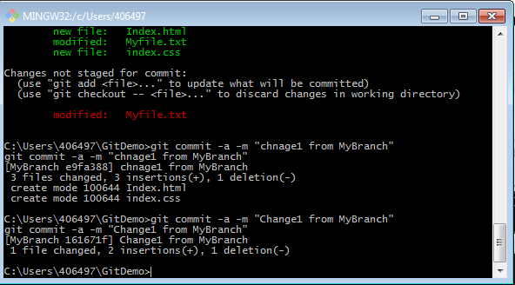

Go back to master, “ git checkout master”: make changes to the same file and merge both file.
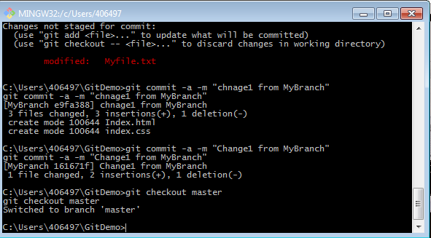

Make changes in the same file and try to merge,
- First of all master branch is not showing changes made from MY Branch
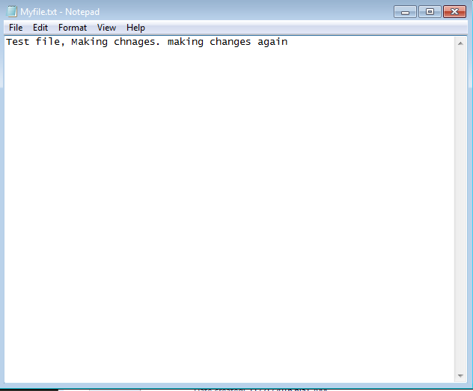
- Also all file are also does not exist in master branch folder.
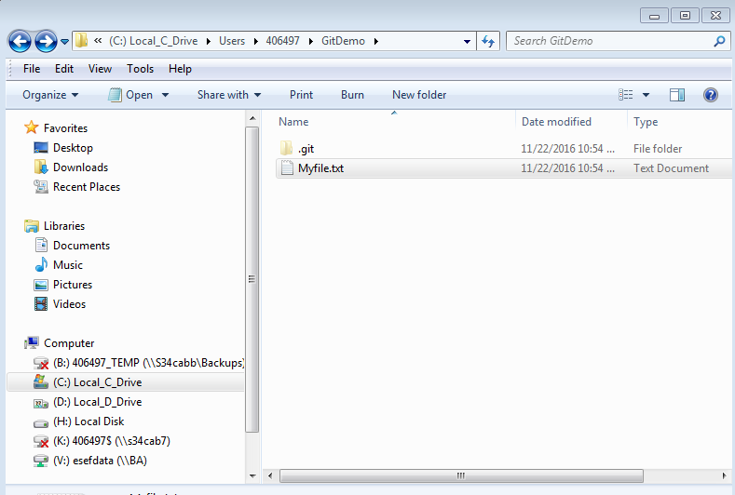

Changes made in Myfile.txt and saved the file.

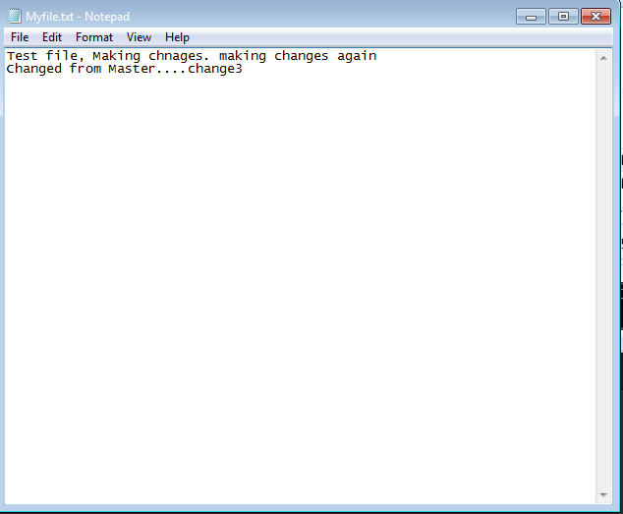

“git commit –a –m” from the master branch:
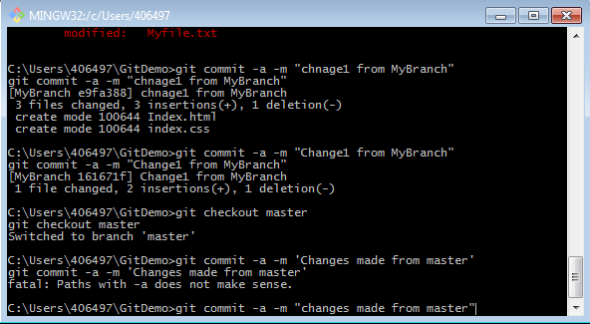

Committed changes from master:

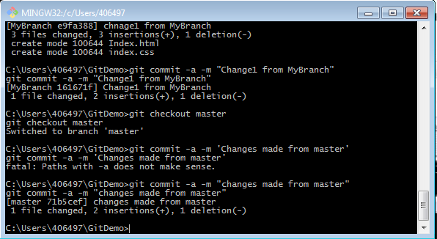

Merge the file: Auto-Merging conflicts
“ git checkout MyBranch” and then
“ git merge master ”

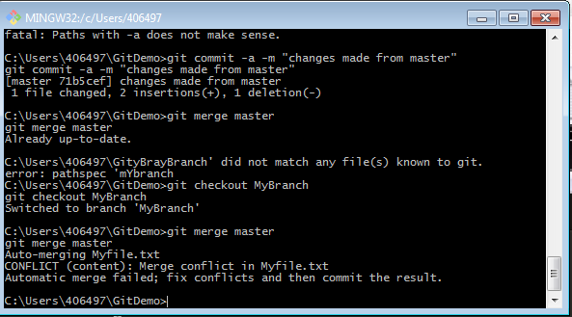
Git shows Auto-merging conflicts and it should be fixed: If we open Myfile it will show the conflicts as mentioned below.

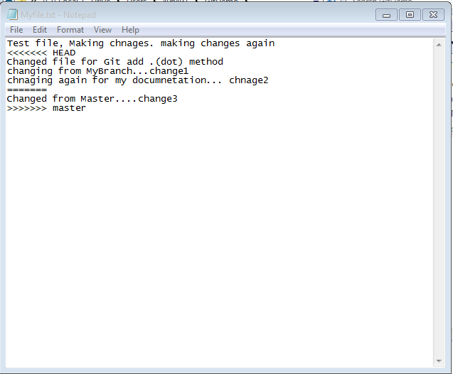

- The top part of the text file with <<<<<<<< Head is from current version
- >>>>>>> bottom part is from the master branch

To fix the problem open the file and delete the marker from the file:
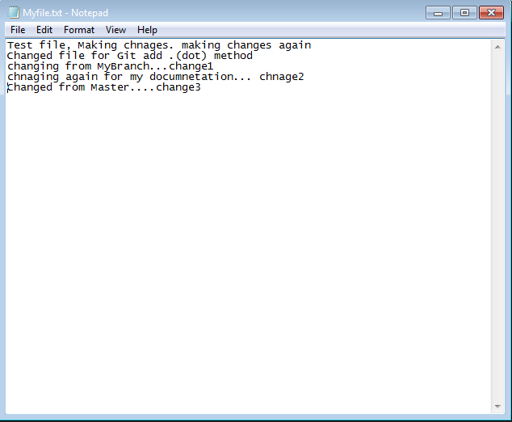

Now we can merge the file :
git commit –a –m “merge from master”

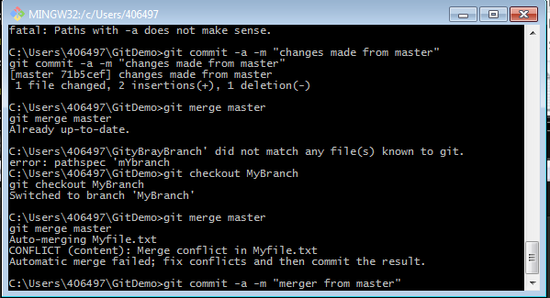

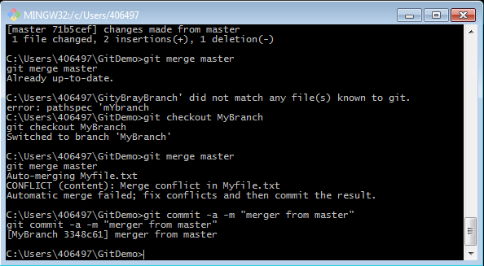

Git Status:
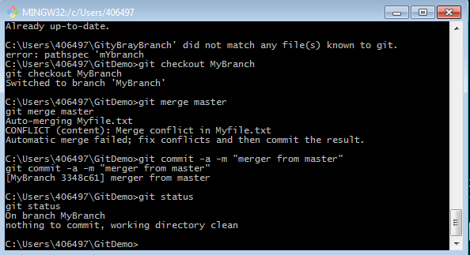

$ git remote show origin
Permission denied (publickey).
fatal: Could not read from remote repository.

Please make sure you have the correct access rights
and the repository exists.

IF user have Permission denied (publickey).
fatal: Could not read from remote repository. Error Try following command on git bash:
$ eval $(ssh-agent)
$ ssh-add C:/Users/userid/.ssh/id_rsa
e.g:
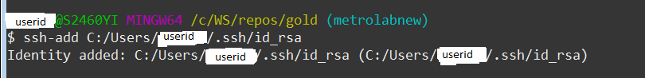

MERV: link of git hub: https://stash.ba.ssa.gov/projects/NLP/repos/merv/browse

Remove username from git:
git config --global --unset-all user.name

Shows all command for configuration
git config--l :
Configure username:
git config --global user.name Shah,Bhavin
Configure User email:
git config --global user.email Bhavin.shah@ssa.gov
Adding-Deleting Remote Branch:
c:\WS\Repos\automation_testing>git remote origin
error: Unknown subcommand: origin
usage: git remote [-v | --verbose]
or: git remote add [-t <branch>] [-m <master>] [-f] [--tags | --no-tags] [--mirror=<fetch|push>] <name> <url>
or: git remote rename <old> <new>
or: git remote remove <name>
or: git remote set-head <name> (-a | --auto | -d | --delete | <branch>)
or: git remote [-v | --verbose] show [-n] <name>
or: git remote prune [-n | --dry-run] <name>
or: git remote [-v | --verbose] update [-p | --prune] [(<group> | <remote>)...]
or: git remote set-branches [--add] <name> <branch>...
or: git remote get-url [--push] [--all] <name>
or: git remote set-url [--push] <name> <newurl> [<oldurl>]
or: git remote set-url --add <name> <newurl>
or: git remote set-url --delete <name> <url>

-v, --verbose be verbose; must be placed before a subcommand

